Deploy NodeJS to Heroku by using

Heroku CLI

Installation
udo npm install -g heroku
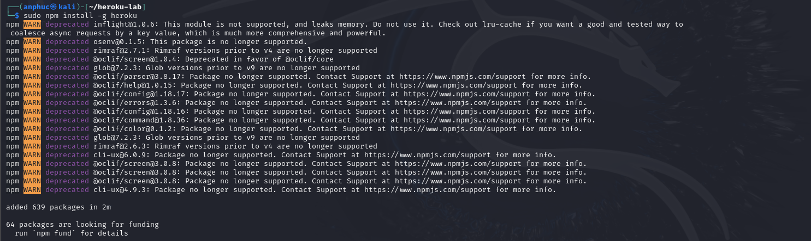
- Check version:
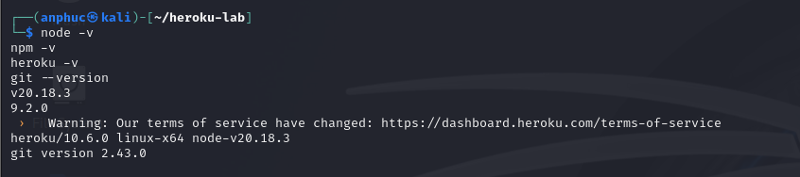

Logging Into Heroku
- Heroku login
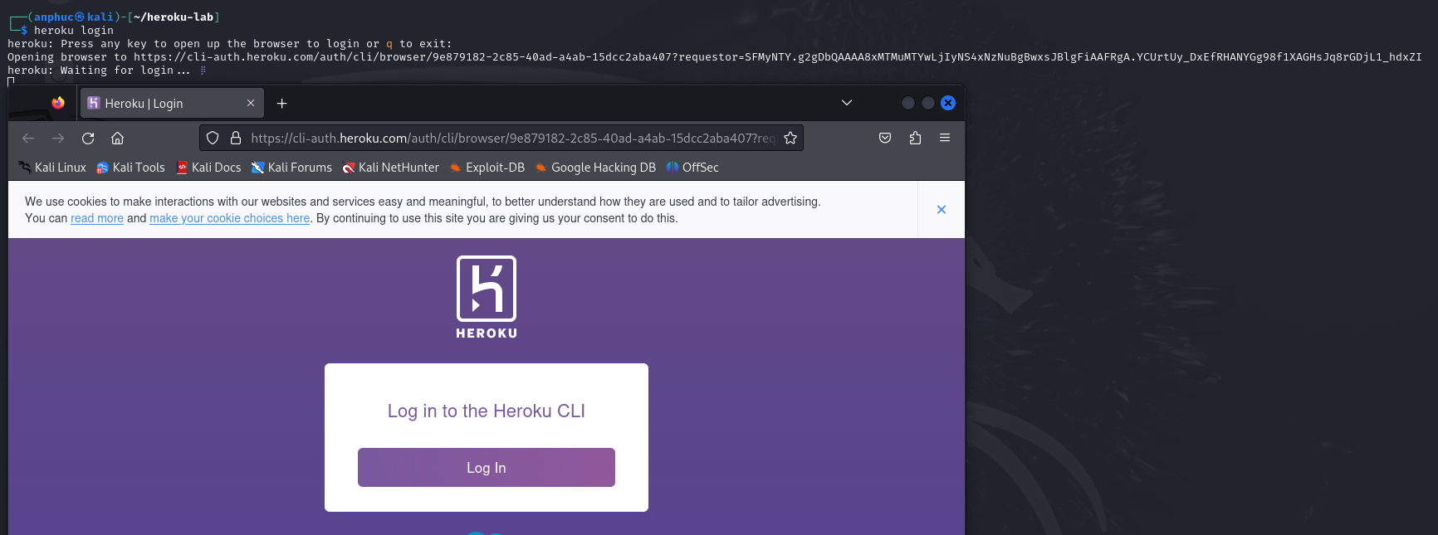
- Login success
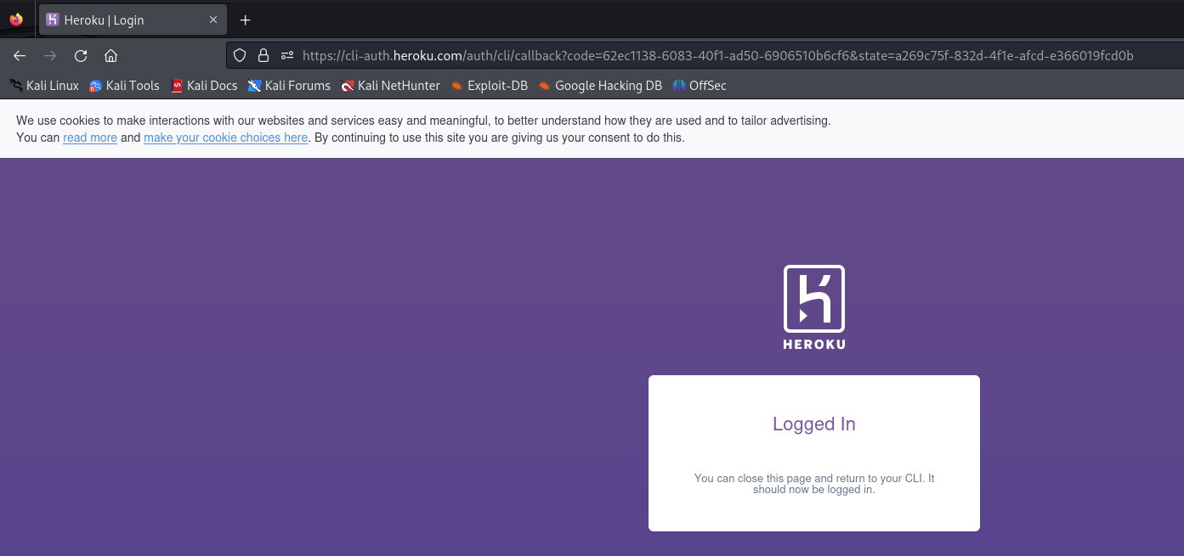

Creating a Simple Node Application

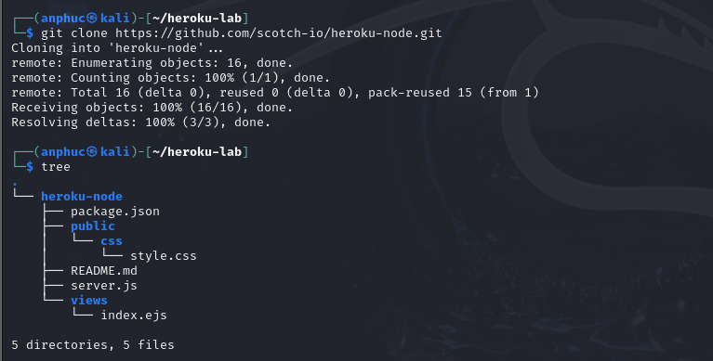

Install required packages
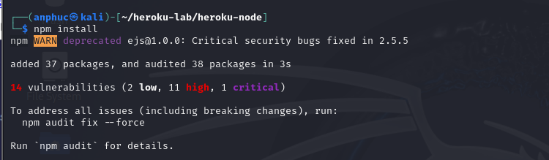

Testing Our Sample App locally
